**What is Collective Impact?**

The collective impact framework is based upon the understanding that no single policy, government entity, or organization can tackle or solve deeply entrenched social problems alone. Moving beyond a partnership or collaboration, collective impact calls for a longstanding commitment between multiple organizations all working toward a common goal. ***It is a model that brings together a network of community members, organizations and institutions that advance equity by learning together, aligning, and integrating their actions to achieve population and systems-level change.*** It is comprised of five key conditions that, if met, will give the Collective a framework for realizing success and implementing the Iowa Blueprint for Change (IBC). *The Collective will share data, create a common agenda, provide opportunities for continuous communication, and self-reinforce by pulling work out of silos.*

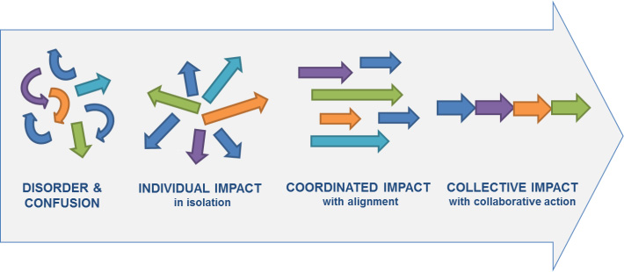

**General Questions and Themes**

* Groups would like more clarity regarding expectations and what success would look like.
* Attendance was good but the collective needs to consist of a more diverse array of stakeholders (people with lived experience, caregivers, family members, businesses, 14C orgs, etc.) and groups need to expand their reach.
* All groups need to consider how they might address the Direct Service Provider (DSP) shortage.
* The vast majority of those in attendance are excited to participate and meaningfully contribute.

**Community of Practice (Objective 1 & 5)**

* More people are needed at the table, particularly individuals with lived experience, businesses, and potential funders (Managed Care organizations and regions).
* Need for continuous recruitment and reevaluation of stakeholders and focus on equity and addressing the needs of those not at the table.
* Next steps are reaching out to those missing groups and identifying the barriers to Competitive Integrated Employment (CIE) for a consistent mission.

**Apprenticeship (Objective 2)**

* DSP shortage is a barrier to other aspects of the IBC.
* Apprenticeship program should include identifying key sectors, engage people, UD/UDL, stackable credentials, diversity, leverage in the credentialing process.
* Include people who want to be a DSP, employers, funders (MCO/Medicaid).

**Youth/Education (Objective 3)**

* Training for parents and Vocational Rehabilitation (VR) staff on options and the transition process.
* Identify pilot sites – establish a total of six pilot centers within the next three years.
* Need to investigate evidence-based strategies and practices with youth, integrating customized discovery, individual placement and supports (IPS) and other programs into school levels and tailor to meet the needs of youth.

**14C, IPS, CE (Objective 4)**

* Intention is not to take things away but to opt for better alternatives – demonstrate to provider organizations that this is a good business decision.
* This is an opportunity to provide education on wraparound services rather than defaulting to workshops.
* Representation in this workgroup should include education, content and context experts, 14(C) certificate holders (and providers that used to hold a certificate and no longer do), employers, individuals who have transitioned from subminimum wage (SMW) to CIE, MCOs/case managers, and mental health providers.

**Policy (Objective 6)**

* Plan to research policies from different states that have been effective and policies that have been received well (Include how robust and far-reaching efforts are).
* First Steps: Establish subgroups within the group to be more effective (identify subgroup leaders and those who want to drive conversation).
  + Executive order
  + Legislation
  + Formal interagency agreements
  + MCO rate change push
  + Phase out 14C(?)
* Group largely consisted of employment/policy/advocacy specialists and professionals. There is a need to identify disability advocates currently benefitting from Employment First and CIE and those who aspire to it, businesses that have benefitted from hiring individuals with disabilities for competitive pay, state representatives from both sides of the aisle, MCO reps, reps from outside organizations, and 14C holders that might be hesitant.
* Identified need for immediate & concise legislative education.